

Oral Methylene Blue Instructions

MB is Contraindicated for the following patients:
- G6PD deficiency, as it can trigger hemolysis (destruction of red blood cells)
- Allergic to Methylene Blue (If you have a known allergy to certain dyes or medications—such as indigo carmine, patent blue V, Brilliant blue or medications like promethazine (Chlorpromazine, Thioridazine, Promethazine, Fluphenazine, Prochlorperazine) — you may also be at risk for an allergic reaction to methylene blue. These substances share similar chemical structures or properties, which can lead to cross-reactivity in sensitive individuals. Allergies to contrast agents used in imaging, like iodine-based or gadolinium-based dyes, may also indicate a higher risk. Be sure to inform your healthcare provider about any past dye or medication allergies before undergoing procedures involving methylene blue.)
- Pregnancy or breast feeding
- Liver and kidney failure
- Current or History of Anemia
- Drug Interactions: Taking Zofran (anti nausea), SSRI, SNRI or MAOI medications, Danger of causing Serotonin syndrome

Benefits:
TheBlu is a proprietary formulation of Methylene Blue and precious metals. It has the following properties:
- Use in infections: Methylene blue has antibacterial, antifungal, and antiviral properties
- Urinary tract infections (UTIs): Sometimes used in combination with other treatments to help manage UTIs or as part of a urinary antiseptic regimen

- Research on neurodegenerative diseases: There's ongoing research into the potential neuroprotective effects of methylene blue in diseases like Alzheimer's disease and Parkinson's disease. Some studies have suggested that it may help protect brain cells by reducing oxidative stress or improving mitochondrial function, though it’s not an approved treatment for these conditions.
- Antidote for certain poisons: Methylene blue has been investigated for its potential to treat poisoning from certain substances, such as cyanide and nitrate, as it may help restore the oxygen-carrying capacity of hemoglobin in these cases.
- ATP Production: Creates ATP for 18-22 hours in the mitochondria, hence enhancing more energy
- Anti-Inflammatory: Oxidative Stress Reduction, Improving Mitochondrial Function, which can influence cellular metabolism and the production of inflammatory mediators. In some experimental models, it has been proposed that enhancing mitochondrial function can help dampen inflammatory responses by stabilizing energy production and reducing cell stress.
Rheumatoid Arthritis (RA): There's some interest in the potential for methylene blue to reduce inflammation in autoimmune diseases like rheumatoid arthritis, though this remains speculative and is still being explored in clinical trials.
Asthma: In experimental asthma models, methylene blue has been shown to reduce inflammation and bronchoconstriction, possibly by its effects on nitric oxide pathways and reducing oxidative stress.
- Inhibition of Monoamine Oxidase (MAO): Methylene blue inhibits the activity of monoamine oxidase (MAO), an enzyme responsible for the breakdown of several neurotransmitters, including serotonin, dopamine, and norepinephrine. By inhibiting MAO, methylene blue may increase serotonin levels in the brain, as it reduces the enzyme's ability to degrade serotonin. Increases memory, cognition and focus, combating fatigue and mental fog. It also has mood-lifting effects

Dosage:
- 5 mg/ml daily (1 full dropper)
- Do Not exceed 1 dropper full daily

Directions:
- Shake Bottle well Before use
- Recommended to place the bottle in front of the Red light LED to activate the ingredients for at least 5 min.
- Once the light turns off, using the supplied dropper, place (0.5 ml) half a dropper full under your tongue (to avoid teeth staining you may place the MB dropper on the back of your tongue or mix in 4 ounces of water in a cup and take it like shot)
- Keep under your tongue and hold for 15 min, then swallow
- Repeat steps 3 and 4 one more time
- Place the bottle back in the fridge after use

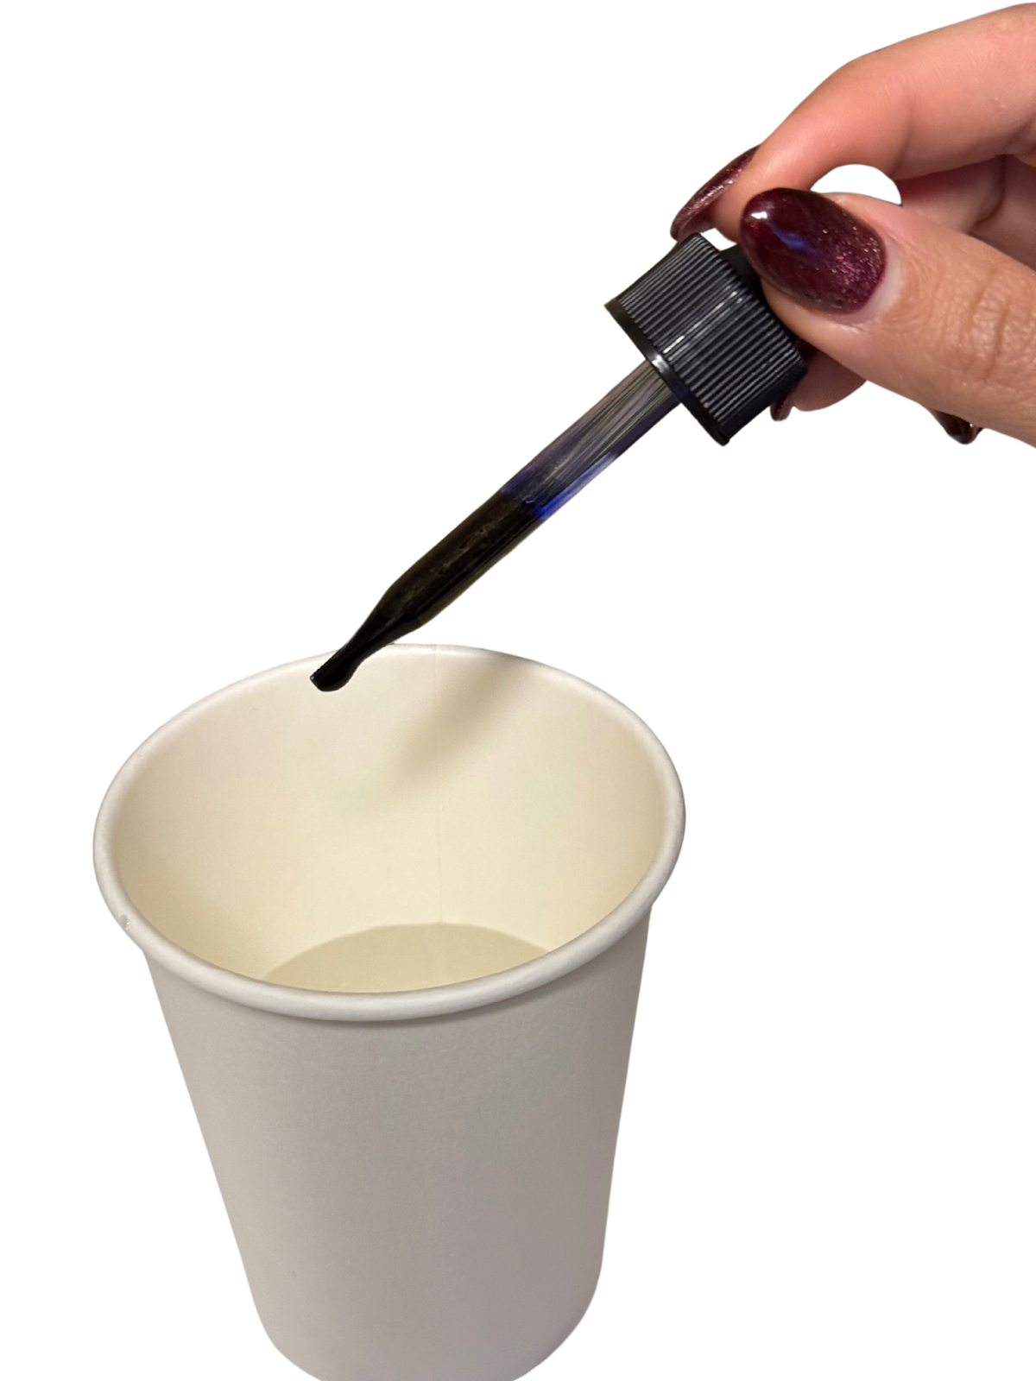

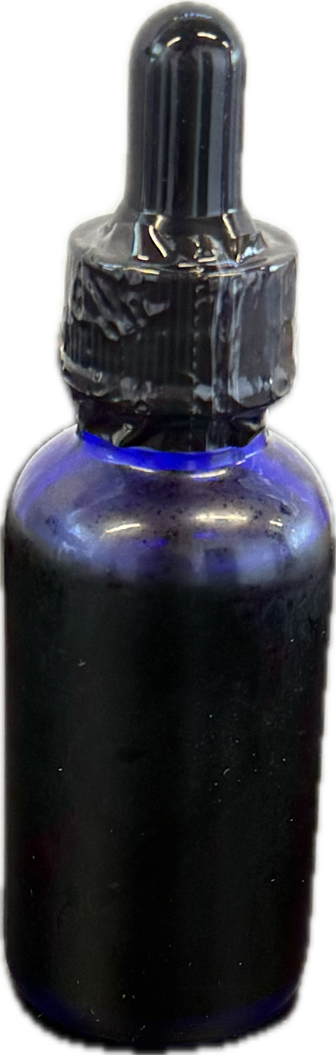

Notes:
- Liquid may temporarily make your tongue and teeth blue in color, to remove the staining place 2-3 tablespoons of fresh lemon or lime juice in your mouth and swish around for 2 min then swallow. You can chew vitamin C tablets as well
- Please be aware that your Urine will turn green color
- Refrigerate after opening

Warning: If you experience signs of an allergic reaction (e.g., rash, itching, swelling, difficulty breathing), discontinue use immediately and seek medical attention.

Disclaimer:
This information is provided for educational purposes only and is not intended to diagnose, treat, cure, or prevent any disease. Always consult with a qualified healthcare professional before starting, stopping, or altering any medication, supplement, or treatment. The information presented here does not replace medical advice from your physician or healthcare provider. Use of this information is at your own risk, and the authors are not responsible for any adverse outcomes resulting from its use.
Consult your primary care physician before use or if you have any concerns

